**DETAIL DESIGN**



**Author: IMAGINEERS**

**Date: 13/01/2017**

**Revision history**

|  |  |  |  |
| --- | --- | --- | --- |
| **Version** | **Date** | **Author** | **Notes** |
| **1.0** | 13/01/2017 | Phuong Nguyen | Created |
|  |  |  |  |
|  |  |  |  |
|  |  |  |  |

Contents

I. INTRODUCTION 4

II. PROTOTYPE 4

1. SWAPPAL_SITE FOUNDATION 4

2. SWAPPAL_FAQS 5

3. SWAPPAL_CONTACT PAGE 5

4. SWAPPAL_VIEW OTHER PROFILE 7

5. SWAPPAL_SEARCH SKILLS 8

6. SWAPPAL_VIEW REQUESTLOG PAGE 8

7. SWAPPAL_REQUEST SWAP 9

8. SWAPPAL_EXCHANGE SWAP 10

# INTRODUCTION

This document is created to show the design GUI or sketches of the Swappal website. This document is create for

* Scrum Team
* Product Owner

# PROTOTYPE

## SWAPPAL_SITE FOUNDATION

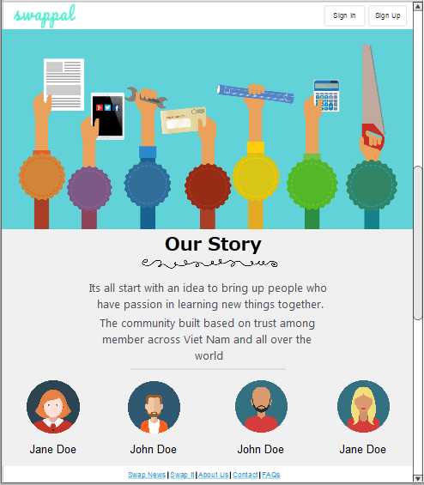

## SWAPPAL_FAQS

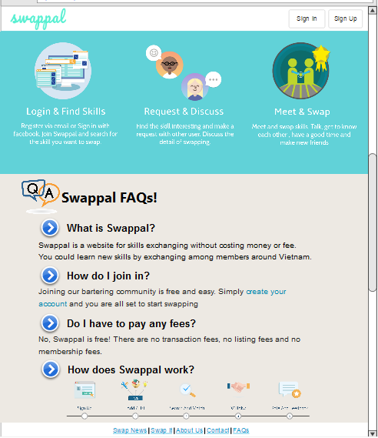

## SWAPPAL_CONTACT PAGE

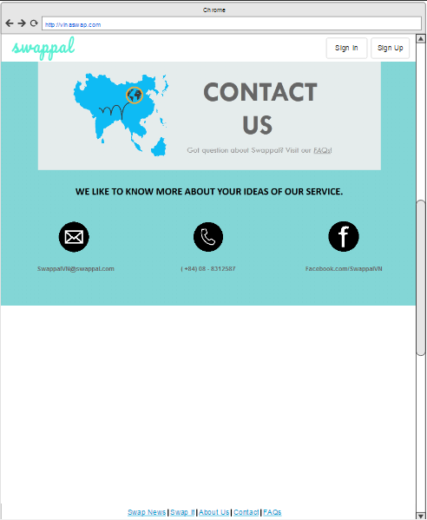

## SWAPPAL_VIEW OTHER PROFILE

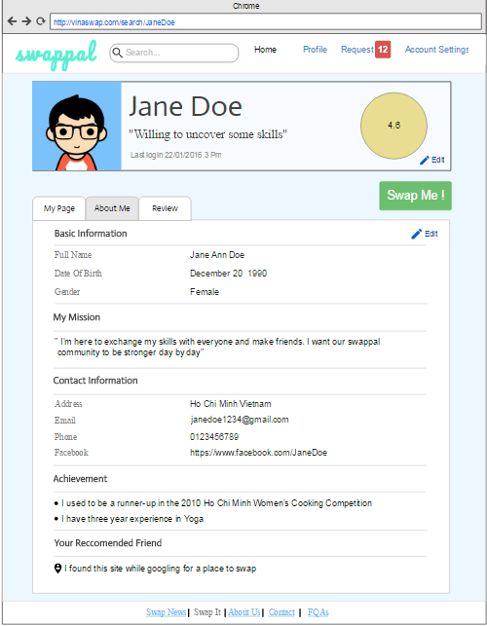

## SWAPPAL_SEARCH SKILLS

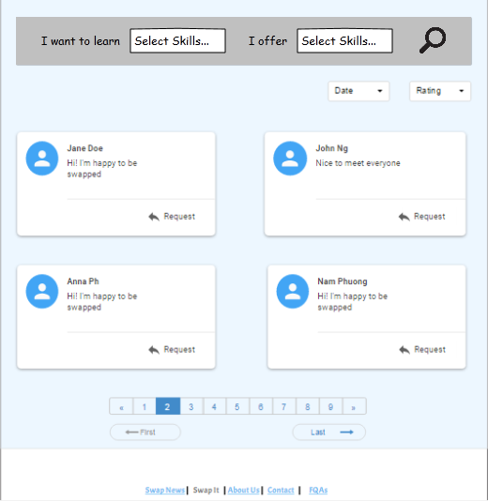

## SWAPPAL_VIEW REQUESTLOG PAGE

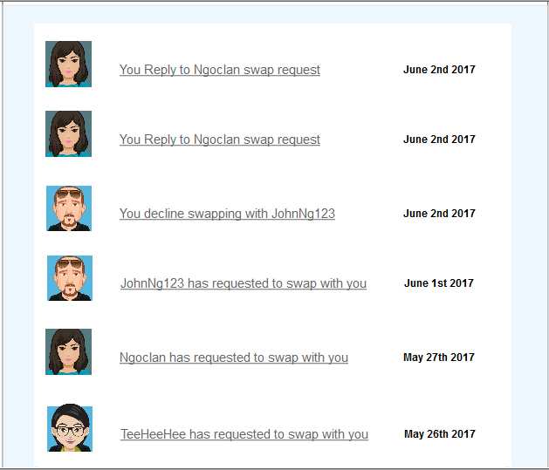

## SWAPPAL_REQUEST SWAP

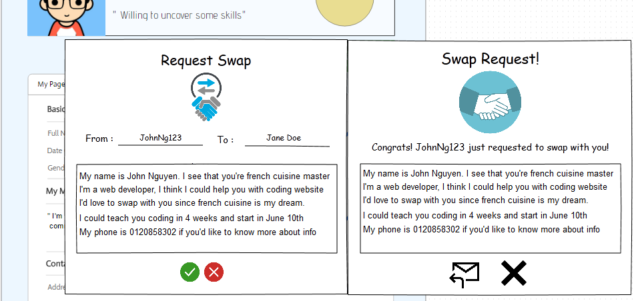

## SWAPPAL_EXCHANGE SWAP

